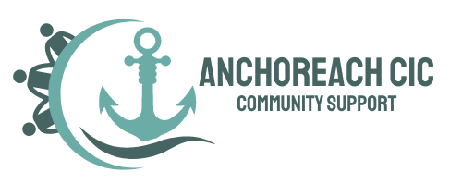

ANCHOREACH C.I.C.

Whistle Blowing Policy and Procedures

Policy Owner: Anchoreach C.I.C.
Approved by: Board of Directors
Date Approved: 17/08/2026
Review Date: 17/08/2027
Version: 1.0

Anchoreach C.I.C. procedure for responding to an incident involving a vulnerable adult

Incident Procedure for a Vulnerable Adult

1. Ensure Immediate Safety
- If the adult is in immediate danger or requires urgent medical attention, call 999 (police, ambulance, or fire as appropriate).
- Remove the person (and others) from harm if safe to do so.
- Stay with the individual until help arrives, if necessary.

2. Listen and Reassure
- Stay calm and approachable.
- Allow the adult to talk, but do not press for details or conduct your own investigation.
- Reassure them they are being taken seriously.
- Avoid making promises (e.g., “I won’t tell anyone”)—explain that you must share concerns with the appropriate people to keep them safe.

3. Preserve Evidence
- Do not tamper with any evidence (clothing, environment, digital records).
- If the incident involves injury, abuse, or crime, preserve items and record observations.

4. Report the Concern
- Inform your line manager or safeguarding lead immediately (or as soon as safe).
- If they are unavailable, or if the concern involves them, follow your escalation procedure (e.g., direct referral to local safeguarding adults team).
- If it is a criminal matter, ensure police are informed.

5. Record the Incident
- Complete an incident report form as soon as possible, including:
  - Date, time, and place of incident.
  - Names of those involved.
  - What was observed, heard, or disclosed (use the person’s own words where possible).
  - Actions taken.
- Stick to facts, not assumptions or personal opinions.
- Sign, date, and submit according to policy.

6. Follow Organisational Safeguarding Procedures
- Cooperate with safeguarding enquiries, investigations, or strategy meetings.
- Maintain confidentiality—share information only with those who need to know.
- Continue to support the vulnerable adult (and others affected) as appropriate.

7. Review and Learn
- Participate in debriefing and reflection after the incident.
- Support staff wellbeing if the incident was distressing.
- Identify any policy, training, or practice improvements needed.

Anchoreach C.I.C. Designated lead is:

Paul Marriner
Managing Director
07950520815
paul@lakota.org.uk

Signed:

If designated lead is unavailable, please contact

Joanne Horner
Managing Director
07894241870
joanne@lakota.org.uk

Policy preparation and review
Policy prepared by Paul Marriner Managing Director of Lakota Hub C.I.C. Policy will be reviewed after 12 months or earlier if there are changes in relevant legislation or in response to any significant incidents or changes in circumstance.

8. Approval
Approved by: Board of Directors
Signature: P Marriner
Name: Paul Marrnier
Position: Managing Director
Date: 17/08/2026
Review Date: 17/08/2027

